Weekly checkup portion:

So far, the group has been able to start the project with sprites being made as the images that will be implemented into the system itself.

**Project description/Proposal Section**

System Scope:

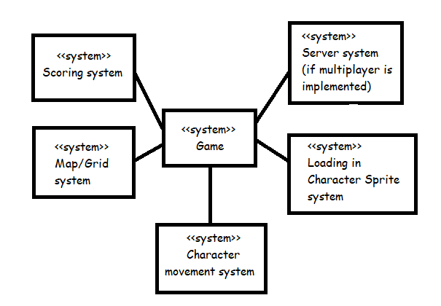

Stakeholders:

The people that will be using the system once it is developed will be the gamers themselves and the developers who have invested their own time into the project. The role of the gamer is to see if the game can function with ease of use. The role of the developers is to give the user an easy-to-use experience while creating a complete game.

Process Description:

Since we are using java there are multiple prerequisites our outlines that could be found relating to how an initial design process can start giving us a number of options to how we can begin development of our game. There is also the background each group member has in c++ and java to consider, while all of our group members have experience coding in c++ only one member has experience using java with will have a major impact on how much can be done at a given time since members will need to learn while designing. Implementing designs for characters or objects in the game was relatively simple due to us using pixel sprites and there already being programs to design said sprites.